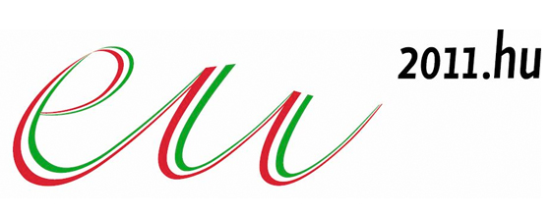
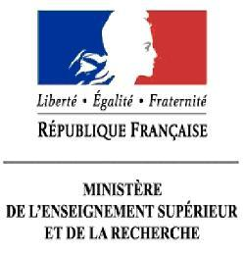
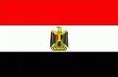
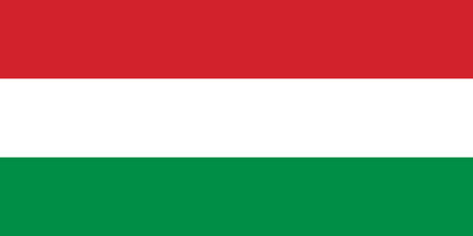

15th Meeting of the Monitoring Committee for the Euro-Mediterranean Cooperation
in Research, Development and Innovation (MoCo)
23-24 June 2011
University of Szeged, Hungary

Provisional Agenda

Thursday 23 June

08:30-09:00: Registration – University of Szeged Congress Centre (TIK), 6722 Szeged, Ady tér 10.

Chair: Hungary / EU Presidency

09:00-09:30 Welcome addresses
- Hungarian EU Presidency, Ferenc Robak, Government commissioner, Ministry of Foreign Affairs
- UfM co-Presidencies
- European Commission, Philippe Froissard, DG Research and Innovation

09:30-09:50 R&D activities at the University of Szeged, Gabor Szabo, President of the University of Szeged

09:50-10:00 Innovative training development in the European Studies Centre of the University of Szeged, Laszlo Trocsanyi, Ambassador, Hungarian Embassy in Paris

10:00-11:00 Tour de Table: Latest developments in the Euro-Mediterranean cooperation
in Research and Innovation (3 min per country)

11:00-11:30 Coffee Break

11:30-12:00 1. Information from the European Commission:
- New structure of the European External Action Service (EEAS), Alexandre Zafiriou (EEAS)
- Stocktaking / upcoming activities on Research and Innovation, Claudio Bogliotti, Aurelie Pancera (DG Research and Innovation)

12:00-12:30 2. Information on the ongoing INCONET MIRA activities
Rafael Rodriguez, Inconet MIRA Coordinator (CSIC)
- White paper of the Euro-Mediterranean observatory
- Research road map in support to H2020
- Euro-Mediterranean fair on Innovation
(Casablanca, December 2011)
- SSH event and other initiatives related to priority-setting
- Overview of the joint calendar activities

12:30-13:00 3. Open discussion on synergies with others EU policies and in particular with ENP (and its instrument ENPI)

13:00-14:30 Lunch Break

Chair: Egypt / UfM co-Presidency

14:30-16:00 4. Programme Level Cooperation in the Mediterranean
a) In the context of FP7
- Information on ARIMNET (consortium representative - tbc)
- Exploring the feasibility of an ERANET PLUS: Presentation of a concept Note, Tarik Celik (TUBA) and Burcak Cullu (TUBITAK)

b) Exploring initiatives and opportunities for other mechanisms of Programme Level Cooperation
- MISTRALS (Mediterranean Integrated Studies at Regional and Local Scales), Etienne Ruellan, (CNRS)
- CMRST (Centre méditerranéen de la recherche
scientifque et technologique), Ghani Chehbouni (IRD)
- Feeding knowledge: Mediterranean Network on Research and Innovation for Food Security, (EXPO2015-CIHEAM)

16:00-16:30 Coffee Break

16:30-17:00 5. Information on the implementation of scientific projects of the UfM,
Ilan Chet, Deputy Secretary General of the UfM

17:00-17:30 6. Preliminary Conclusions

19:30 Reception – City Hall, 6720 Szeged, Széchenyi tér 10.

24 June (Friday)

Chair: France / UfM co-Presidency

09:00-09:30 7. Identifying initiatives on a regional programme for Innovation
- From a Bilateral to a Regional approach, Rafael Rodriguez (MIRA project)
- CMI/EIB - DG Research/MIRA cooperation, Philippe Guinet (EIB)

09:30-10:00 8. Discussion on the next Ministerial Conference on Higher Education,
Research and Innovation: Research and Innovation issues (open discussion)

10:00-10:30 Coffee Break

10:30-11:00 9. Proposals for the creation of a Euro-Mediterranean Research Area
(open discussion)
11:00-11:30 10. Any other business
11:30-12:00 11. Conclusions, next steps and road map
12:00-12:30 12. Closing remarks
- Hungarian EU Presidency, Laszlo Dux, Deputy State Secretary for Higher Education and Science Policy, Ministry of National Resources
- UfM co-Presidencies
- European Commission

12:30-14:00 Reception – University of Szeged, Central Building, 6720 Szeged, Dugonics tér 13.

Departures

