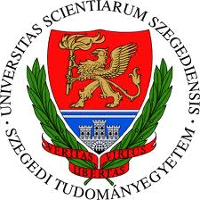

SZENT-GYÖRGYI ALBERT AGORA – INFORMATORIUM – PARTNERS MEETING

Szeged, 28 June 2012

Place of the conference: SZTE TIK, 6722, Szeged, Ady tér 10.

Programme

      - Registration

      - Introductory speech
Tamás Susányi, CEO of DEAK Plc.

      - Welcome speech
Dr Béla Rácz, vice-rector of SZTE (University of Szeged)

11.15-11.30 The strategy of development – tendering and cooperation opportunities in partnership with SZTE
Dr Miklós Lukovics, director of SZTE’s Strategy and Development Directorate

      - The role of innovation – utilisation, results, experiences
Dr Norbert Buzás, director of SZTE’s Research, Development and Innovation Directorate

11.45-12.00 Introducing the Szent-Györgyi Albert Agora and Informatorium (a presentation)
Dr László Z. Karvalics, senior executive of SZTE

12.00-12.45 Roundtable discussion – discussing opportunities

12.45-14.00 Buffet reception

14.00-15.00 Szent-Györgyi Albert Agora – A tour around the site*

*Since the guided tour takes place at a construction site, only a limited number of guests can visit the new Agora. Applications are accepted in the order of registration. Participants will be transported to the site free of charge by the Szeged Sightseeing Train.

