Acknowledgement

SIWAN is the joint effort of many individuals and organizations. First and foremost, we are indebted to our mentor and friend, the late Prof. Imre Kiricsi who initiated the SIWAN series a decade ago. We thank the Hungarian nanoscience community, in particular Profs. Katalin Kamarás, Imre Dékány and László P. Biró for their continuous support of SIWAN. Thanks are also due to our colleagues at the Department of Applied and Environmental Chemistry of the University of Szeged for their assistance in numerous practical issues and to the staff of the Akadémiai Kiadó (Erna Sári and Balázs Réffy) for their faith and dedication to SIWAN.

SIWAN 2012 is the dedicated dissemination event of the projects in which our research groups are involved today. All of the following projects have provided support to the conference.

EC FP7 CP “THEMA-CNT” #228539  http://themacnt-fp7.com | 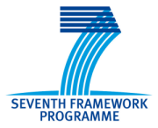
EC FP7 INCO “NAPEP” #266600
http://napep.net
EC FP7 CP “SusFoFlex” #289829
http://www.susfoflex.com
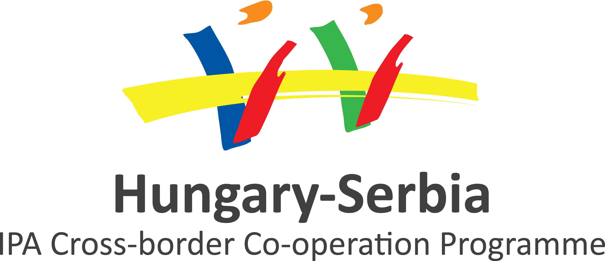 | Hungarian-Serbian IPA “MATCROSS” 1002/214/188  http://www.pmf.uns.ac.rs/en
MTA-SZTE Reaction Kinetics and Surface Chemistry Research Group  MTA-SZTE “Lendület” Porous Nanocomposites Research Group | 
 | TÁMOP-4.2.2.A-11/1/KONV-2012-0047  TÁMOP-4.2.2.A-11/1/KONV-2012-0060

