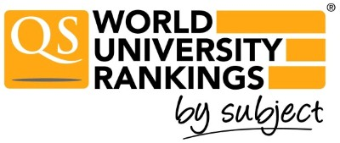

QS World University Rankings by Subject | Results | Methodology

University of Szeged
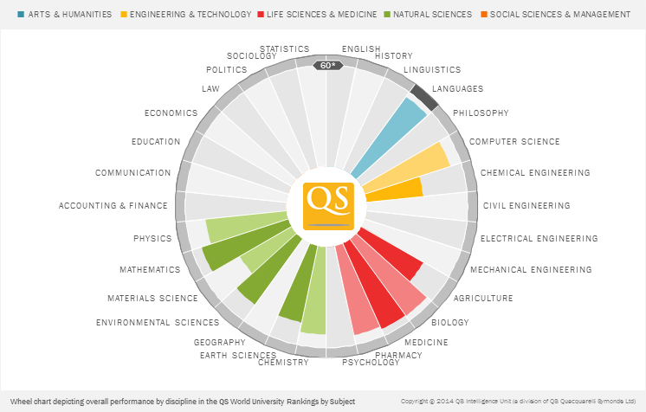

Subject | Academic | Employer | Citations | H | Score | 2014 Rank
ARTS & HUMANITIES
Modern Languages | 53.4 | 63.7 | n/a | n/a | 56.7 | 101-150
ENGINEERING & TECHNOLOGY
Computer Science & Info Systems | 43.4 | 56.1 | 67.3 | 59.0 | 53.2 | >200
Engineering - Chemical | 26.8 | 39.5 | 49.0 | 26.0 | 33.8 | >200
LIFE SCIENCES & MEDICINE
Agriculture & Forestry | 43.0 | 17.0 | 49.9 | 46.3 | 42.5 | >200
Biological Sciences | 52.5 | 61.5 | 71.2 | 45.8 | 56.4 | >200
Medicine | 48.3 | 63.1 | 77.0 | 43.5 | 55.8 | >200
Pharmacy & Pharmacology | 48.2 | 47.2 | 68.1 | 52.3 | 54.1 | >200
NATURAL SCIENCES
Chemistry | 46.5 | 58.4 | 62.1 | 46.6 | 52.0 | >200
Earth & Marine Sciences | 52.1 | 58.0 | 44.7 | 34.8 | 46.6 | >200
Environmental Sciences | 52.9 | 52.6 | 48.4 | 38.7 | 48.2 | >200
Materials Science | 17.0 | 41.2 | 52.3 | 46.0 | 35.4 | >200
Mathematics | 58.9 | 54.3 | 51.6 | 46.6 | 54.1 | >200
Physics & Astronomy | 46.1 | 52.7 | 50.0 | 45.8 | 48.2 | >200
© 2014 QS Intelligence Unit (a division of QS Intelligence Unit)

