29th May 2024

2026
ICOSTEE

International Conference
on Science, Technology,
Engineering and Economy


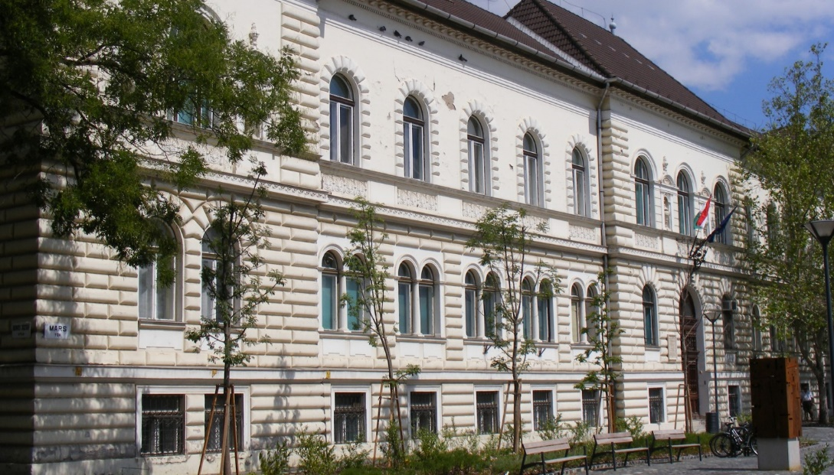

Faculty of Engineering University of Szeged

International Conference on Science, Technology, Engineering and Economy

ICOSTEE 2026

Preliminary
CONFERENCE PROGRAM

29st May 2026

Organized by
Faculty of Engineering University of Szeged
Szent-Györgyi Albert Agóra, 6722 Szeged, Kálvária sgt. 23.

Preliminary scientific program
10⁰⁰ – 10¹⁵ | Opening, conference introduction
10¹⁵ – 11¹⁵ | Pleanary lectures
Prof. Dr. Barbaros Özer
Novel and innovative food processing technologies from an ethical approach perspective research
- Dr. Orsolya Ferencz

11¹⁵ – 12⁰⁰ | Break
Poster session – continuous
12⁰⁰ – | Oral presentations (Sessions)
12⁴⁵ – | Lunch
14⁰⁰ – | Oral presentations (Sessions)
Poster session – continuous

