La Petite Glove Box
Ergonomical, Effective, AND Economic!
The La Petite Glove Box is comprised of essentially only two components. The top and bottom are sealed using a revolutionary new gel used in the clean room industry.  The unit is only two-thirds the size of our "Basic Glove Box", (818-GB). The 815-PGB is designed to be ergonomically correct for the average person. | 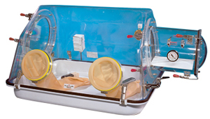
  815-PGB, La Petite
  I.D. |  | 80 x 65 x 55 cm
  O.D.* |  | 124,5 x 74 x 56 cm
  Appx. |  | 269 L
  Appx. |  | 135 Kilos
  * Includes Transfer Chamber
  815-PGB, La Petite Glove Box
Basic Features
• | Lightweight, easy to move from lab to lab.
• | Optically clear, one piece formed top is unbreakable.
• | Bright white one piece bottom formed out of high temperature Noryl has "easy clean" corners.
• | Gel Sealant.
• | Stainless steel clamps have security locking features.
• | Large access door (12" opening)
• | Four ground key-cock valves for purging and gas entry.
• | Adjustable Rh gauge.
• | "Weathertite" duplex electrical outlet with safety covers.
• | Transparent vacuum capable transfer chamber 12" long x 9.75" ID.
• | White leveling plate for transferring liquids.
• | All stainless steel clamps are adjustable.
• | Vacuum gauge on transfer chambers.
• | 7" Latex or neoprene gloves available.
• | Standard 12 month warranty.

 | To replace gel oder 800 blue.
  Gel Sealant System
  This new gel was developed specifically for the clean room industry. It was first used for secure sealing of the HEPA filter system.
  • | The gel does not support biological growth.
  • | It will not "outgas" and is non toxic.
  • | It contains no silicone which might cause contamination.
  • | It is an air tight, water tight barrier.
  • | It is highly adhesive yet quick releasing and self healing.

Basic Glove Box  Clearly your best choice. | 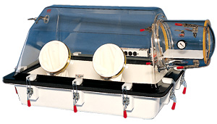
  818-GB
Our glove boxes are designed to be just what they are called, "Basic." They are engineered to fit general laboratory isolation applications. They can be easily modified for specific uses.
Units are very handy for isolating sensitive research studies from a hostile exterior environment.
These economical units are compact, portable, lightweight and self-contained.
Basic Features for Models 818-GB and 818-GBB
• | Optically clear, one piece acrylic top.
• | Matched die molded thermoset, bright white bottom (818-GB only).
• | Coved, easy to clean corners with no hidden dark spots.
• | Double layered, closed cellular neoprene gasketing system.
• | Ambidextrous, white Hypalon gloves for superior chemical and U.V. resistance.
• | Adjustable vacuum gauge on transfer chamber.
• | Four ground key cock valves for purging.
• | White leveling tray for transferring liquids through the transfer chamber.
• | Stainless steel "0" rings for gloves.
• | Transparent transfer chamber 12" long by 11" diameter (l.D.).
• | Standard warranty (12 months).
• | All clamps fully adjustable to compensate for wear.
• | Hospital grade multiple electrical outlet strip U.L.-C.S.A. approved 110-120 volt U.S.A. (220-240 volt export).

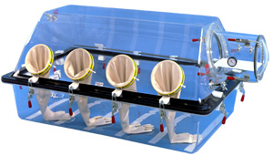
  818-GBB
  Sizes | 818-GB | 818-GBB
  I.D. | 104cm x 71cm x 66cm | 152cm x 96.5cm x 79cm
  O.D. | 140cm x 89cm x 68.5cm | 193cm x 119cm 81cm
  Appx. Shipping Weight | 180 kg | 240 kg
  Volume | 489L | 1157L
  818-GB shown with additional accessories: 800-Flow (flow meter kit) and 800-PORT (extra glove ports on back of chamber).

Glove Box Applications
< back

Closed Loop Containment Isolator
Biocontainment Level III
The Closed-Loop Containment Isolator is a completely automated negative pressure glove box.  The system is engineered and programmed to maintain a slight negative working pressure ( -0.50 in H2O ). The internal atmosphere is continually filtered by two HEPA filters. Filters are rated at 99.9997% efficiency.  These isolation units may be coupled together for multiple station work processes. They are large enough for four (4) sets of glove ports (operators). | 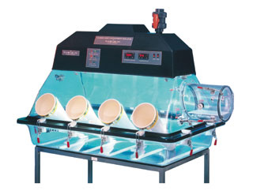
  870-CLC, Closed-Loop Containment Isolator
  I.D. | 56"w x 35"d x 27"h | 142 x 89 x 69 cm
  O.D.* | 82"w x 47"d x 53"h | 208 x 119 x 135 cm
  Appx. Vol. | 40.0 cu. ft. | 1157 Liters
  Appx. Ship. Weight | 300 pounds | 135 Kilos
  870-CLC, Closed-Loop Containment Isolator
Basic Features
• | Effective containment / isolation of potentially hazardous toxins, organisms, etc.
• | Completely sealed system with automatic negative pressure control.
• | Large, easy to read control panel with digital controllers and LED status lights.
• | Inlet / outlet HEPA filtration.
• | Easy to clean, highly radiused corners.
• | Clear acrylic construction will not cause unwanted shadows.
• | Fluorescent light offers a well lit, bright working environment.
• | Manual house exhaust valve for rapidly venting the isolator.
• | Two pairs of glove ports for multiple operators.
• | Ambidextrous, white Hypalon gloves.
• | Plas-Labs quality customer service.
• | Stainless steel support cart with gas tank support tracks.

