Technical specification of Call for proposals No SZTE/2022/PB12181
20-HETE and 20-HETE-d6 oxylipin standards
# | Product name | Specifications | Qty
1 | 20-HETE  CAS Registry No.: 79551-86-3  Formal Name: 20-hydroxy-5Z,8Z,11Z,14Z-eicosatetraenoic acid  Synonym: 20-hydroxy Arachidonic Acid  MF: C20H32O3  FW: 320.5 | 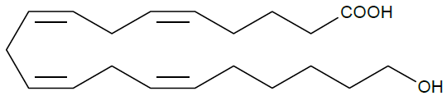  Purity: ≥98%  Stability: ≥1 year at -20°C  Supplied as: A solution in ethanol  500 μg active ingredient content (as solution).  Concentration is not defined.  Transport refrigerated. | 500 μg
2 | 20-HETE-d₆  CAS Registry No.: 2548939-89-3  Formal Name: 20-hydroxy-5Z,8Z,11Z,14Z-eicosatetraenoic- 16,16,17,17,18,18-d₆ acid  Synonym: 20-hydroxy Arachidonic Acid-d₆  MF: C20H26D6O3  FW: 326.5 | 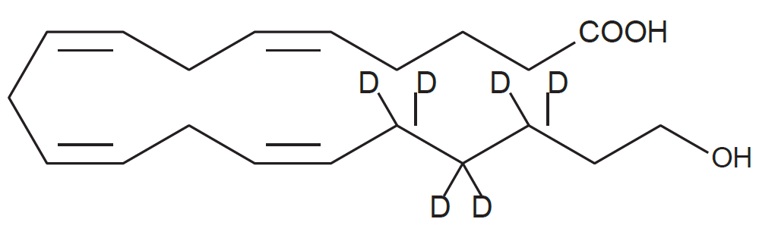  Chemical Purity: ≥95% (20-HETE)  Deuterium Incorporation: ≥99% deuterated forms (d1-d6); ≤1% d0  Supplied as: A solution in acetonitrile  Storage: -20°C  Stability: ≥2 years  100 μg active ingredient content (as solution).  Concentration is not defined.  Transport refrigerated. | 100 μg
3 | Please include shipping cost to delivery address (Szeged, Hungary)
Formal requirements of the quotations. Please include these data in your proposal:
- Please refer to SZTE/2022/PB12181
- Name of the bidder company, address. Please note that the bidder's company name must be same as that of the contracting and invoicing company (In case the bidder company outsources the invoicing, please notify us before the tender deadline).
- The NET price for both products + all the expenses (e.g. shipping to Szeged, Hungary; handling etc.) of the purchase. Please note that in case shipping/handling cost is not clearly listed in the offer, we will assume that the total cost includes shipping/handling cost, and no further shipping/handling cost can be charged.
- Please list unit prices, subtotals and net total. Please note that quoted net price (subtotals and totals) must match the prices listed in the final invoice to be issued upon delivery. (In case a bidder needs to pay additional taxes, fees, licenses etc after the products/services offered, they are kindly requested to be aware of that and consider these extra cost when calculating the offer net total price.)
- Please do not list the bank charge (to be paid by customer).
- Terms of delivery and delivery/lead time.
- Terms of payment (such as: net 30 days or prepayment). Our University prefers to pay with wire transfer.
- Quote validity and/or quote issue date. The quotation should be preferably valid for 60 days, due to excessive evaluation period, but at least for 30 days.
  - Quote validity day should be not earlier than the deadline of the procedure.
  - Quote issue date should not be earlier than the starting date of the call for proposals.
- Please include the specification in your offer (so that it can be clearly evaluated whether it matches all the specified features).

Please upload your offer on the website of the Call for the Proposals, No SZTE/2022/PB12181

