Leírás | Menny. (db)
DN 100 CF to DN 40 CF Reducing angled port with through-hole bolt hole non-rotatable flanges on each side, Stainless Steel 304  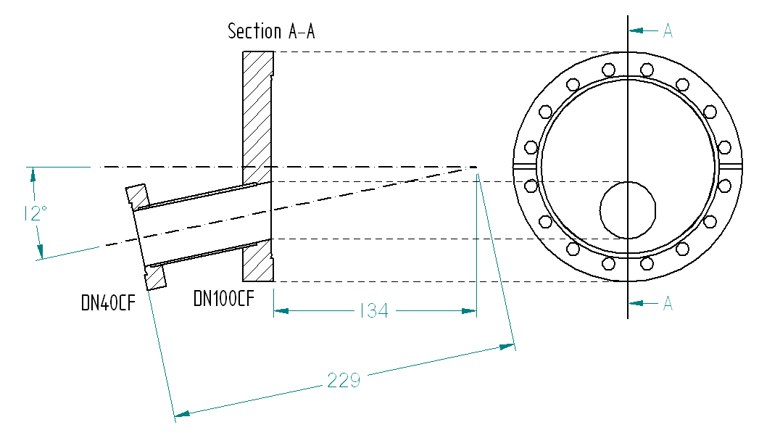 | 1
DN 40 CF Highly Flexible Corrugated Hose Connector, Same size flange each end, One flange rotatable, Stainless Steel 304, Overall Length: 375 mm | 1
DN 40 CF Highly Flexible Corrugated Hose Connector, Same size flange each end, One flange rotatable, Stainless Steel 304, Overall Length: 250 mm | 1
DN 40 CF 4-Way Cross, One rotatable flange on each axis, Through-hole bolt hole flanges, Stainless Steel 304 | 1
DN 40 CF Tee, Through-hole bolt hole flanges, Stainless Steel 304 | 1
DN 40 CF Elbow, 90° (Radius), Through-hole bolt hole flanges, Stainless Steel 304 | 2
DN 40 CF Non-rotatable Blank flange, Through-hole bolt holes, Stainless Steel 304 | 1
DN 40 CF General purpose UHV Viewport (7056 Glass) | 1
DN 100 CF Electropneumatically actuated Million cycle Gate Valve with Mechanical position indicator, Flange threads: M8, Bonnet seal: Metal, Supply: 230 V, 50 Hz | 1
UHV compatible Kapton insulated ribbon cable, No. of wires: 15, Length: 1000 mm | 1
DN 40 CF Oxygen free high conductance (OFHC) Copper Gasket | 10
DN 40 CF Viton Gasket | 5
DN 16 CF Viton Gasket | 5

